NYSCC Suppliers’ Day 2016: Imerys will showcase two new additions to its ImerCare™ mineral range: ImerCare Velluto and ImerCare 190P-Scrub
ImerCare mineral additives for personal care and cosmetics formulations

Imerys Minerals will showcase two new additions to its ImerCare™ natural, mineral range at the New York Society of Cosmetic Chemists Suppliers’ Day 2016:

ImerCare 190P-Scrub natural microspheres are the ideal, 100% natural alternative to plastic beads in face scrubs. ImerCare 190P-Scrub is derived from perlite, a natural volcanic rock. It has been specifically engineered to obtain particles with a unique spherical shape and a controlled particle size distribution, resulting in gentle physical exfoliation, ideal for face applications. ImerCare 190P-Scrub microspheres are easy to use and can be added at a much lower dosage level than plastic scrub particles while maintaining the desired exfoliation.

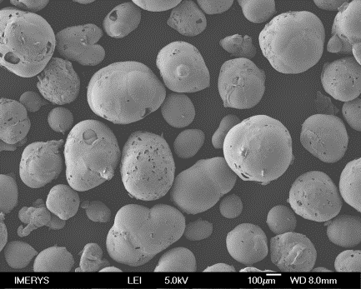

ImerCare 190P-Scrub’s natural microspheres are a natural alternative to plastic beads, conferring a gentle exfoliation effect, ideal for face scrubs.
ImerCare 190P-Scrub for face scrubs rounds out the existing Scrub range featuring 270P-Scrub and 400P-Scrub grades for body scrub and spa applications.
ImerCare Velluto imparts superior coverage in pressed powder foundations. Derived from 100% natural magnesium silicate, ImerCare Velluto has been engineered using patented technology to obtain an innovative structure which enhances cohesion and imparts multiple optical and sensory properties to make-up powders.

In concealers and foundations, ImerCare Velluto confers high coverage and imparts a silky, unctuous feel, an even skin look and a smooth satin finish.

ImerCare Velluto’s high power of cohesion also improves compaction, rendering pressed powders more resilient to breakage. Unlike many mineral powders on the market, ImerCare Velluto can easily be used in wet processes and prevents cracking.

Visitors to the Imerys Booth (1122) will be able to learn about new mineral additives, including ImerCare 190P-Scrub, Velluto magnesium silicate as well as kaolins and diatomaceous earth grades from the ImerCare natural, mineral range.

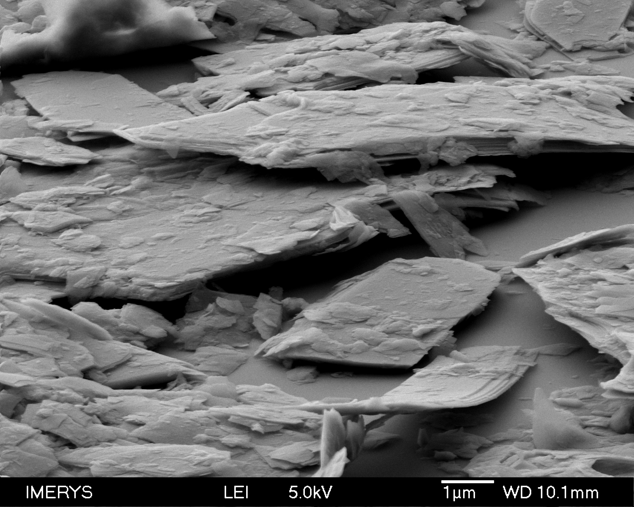

ImerCare Velluto has been engineered using patented technology to obtain an innovative structure which enhances cohesion and imparts multiple optical and sensory properties to make-up powders.
The ImerCare range is Ecocert certified. This accreditation underscores the “naturalness” of the minerals selected and produced by Imerys for the cosmetics industry, and which offers a host of new development opportunities.

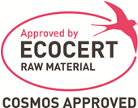

About Imerys Group
Imerys is the world leader in adding value to minerals. With more than 250 sites in 50 countries worldwide, the Group achieved over €4 billion in sales in 2015. Combining high-quality mineral resources with advanced industrial know-how and technologies, Imerys designs, manufactures and sells mineral-based specialties that enable customers to improve product performance or process efficiency.
Visit Imerys Minerals at Booth 1122.

Press Contact: Cindy Stoutenborough: 805-562-0210 e: cindy.s@imerys.com

